10-12th June 2015
My trip to Canberra
The whole of stage 3 went on a journey to Canberra to explore the government and all native places around Australia including the royal Australia mint, War memorial, and also Mt Kosciuszko National Park, after we went to our cabins. The next day we went to the museum of democracy to discover more about the olden days then after we went to new parliament house to learn about the government then after we went to the Australian War Memorial to learn about the people who fought for our country. The other places we went to were Questacon. In there we were buying all these different toys then all the other activities. Then we went home and went to go get our bags.
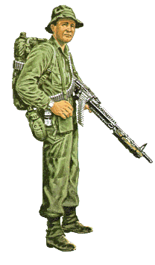
From Luke

